TAGS
ANNUAL MEETING & BOARD OF DIRECTORS MEETING
June 7, 2023
Minutes
- At 1:34 pm Eric called the Annual meeting to order and made introductions.
Eric moved approval of the new member slate; it passed unanimously.
The Annual meeting adjourned at 1:37 pm.
- The June TAGS Board of Directors Meeting was called to order at 1:37 pm. Lauma moved to approve the April 2023 minutes; Greg seconded.
Doug moved approval of the Executive Committee 2021 Slate; Peyton seconded.
- Greg provided the treasurer’s report from June 1, 2022-May 1, 2023
- Zamir Mirza with VDOT provided an update on the Frontier Drive Extension Project. It is funded with Fairfax County local funding, and NVTA regional money; however the County is still seeking additional funding through NVTA to fully fund it. The current anticipated project schedule is: Design approval: Summer 2023, Field Inspection: Fall 2023, Right of Way: Spring 2024, and Construction to start in 2027 (dependent on funding). Dominic asked about the connection on the east end—have there been any design changes on the new trail connection? Zamir said he was uncertain but that it should be unchanged.
Holly asked who does the design approval? Zamir said first it is Fairfax County and it was approved earlier this year.
Doug asked whether Zamir would be the best point of contact with further questions; Zamir said yes and shared his email address: zamir.mirza@vdot.virginia.gov
His full presentation is the clickable power point presentation below.
- Michael Felschow introduced Christian Bissai who gave a ridership update on the TAGS routes. He said there was a slight ridership increase over the winter months and shared average and monthly ridership numbers by route. Screenshots are below:
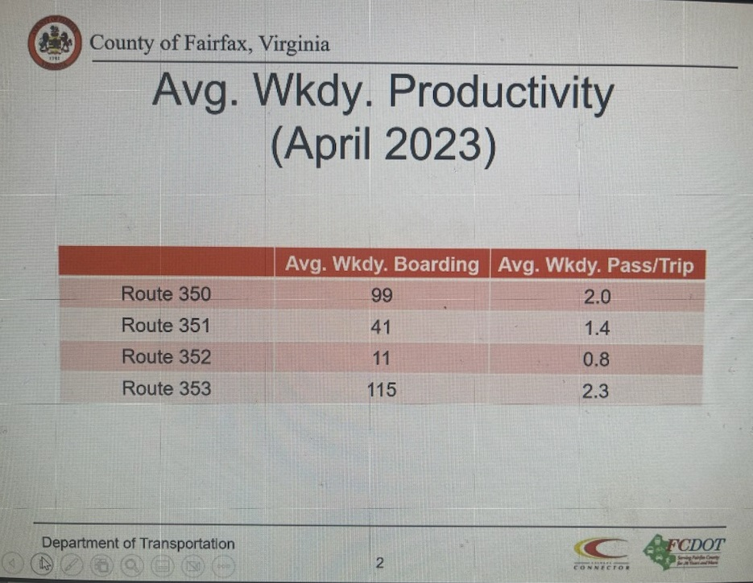
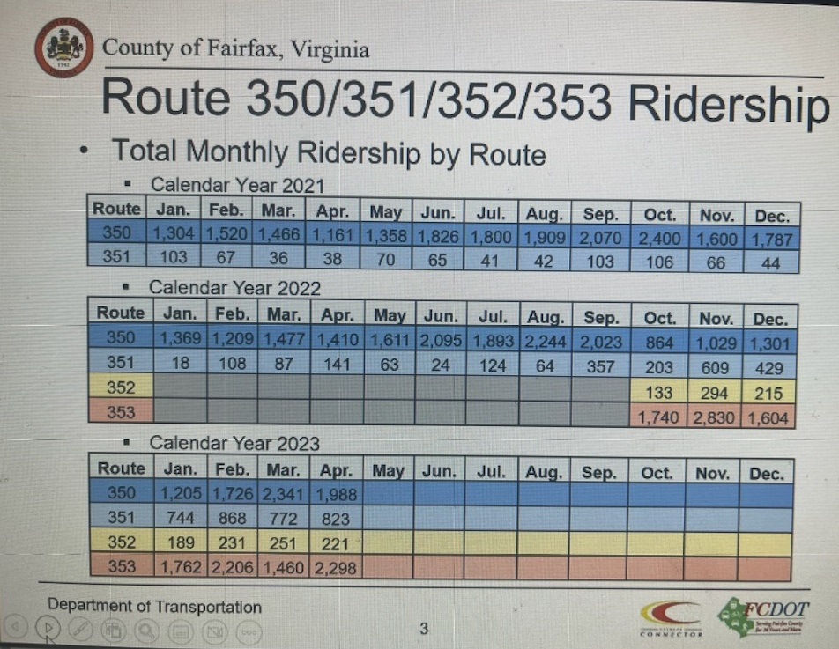
- Susan Shaw with VDOT Megaprojects introduced Todd Horsley at DRPT who presented regarding the I-495 Southside Extension Environmental Study. He emphasized it is a study, not a plan and was initiated by DRPT to inform VDOT’s 495 Southside Express Lanes Study. He discussed the study area, the engagement process to date, the study recommendations, schedule and next steps. Screenshots from his presentation are below:
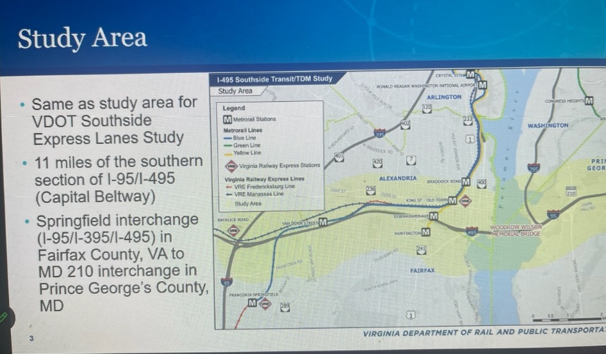
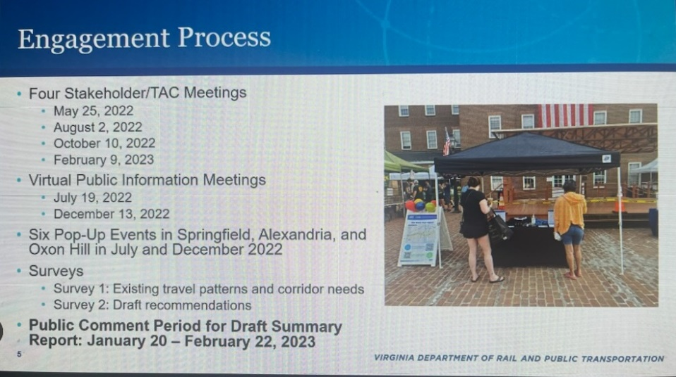
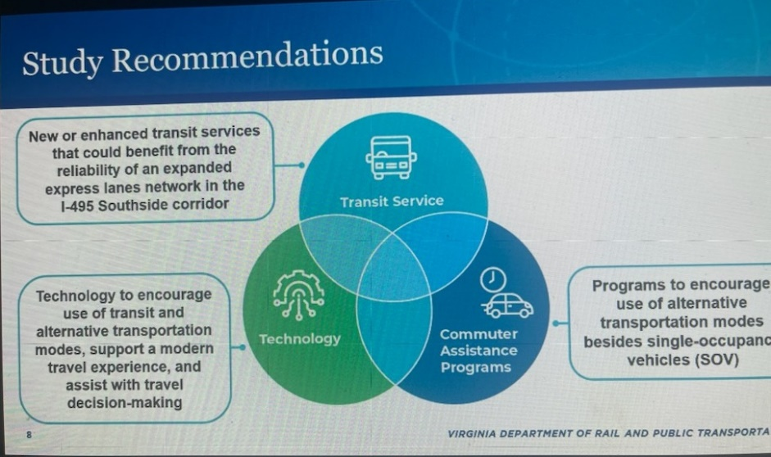
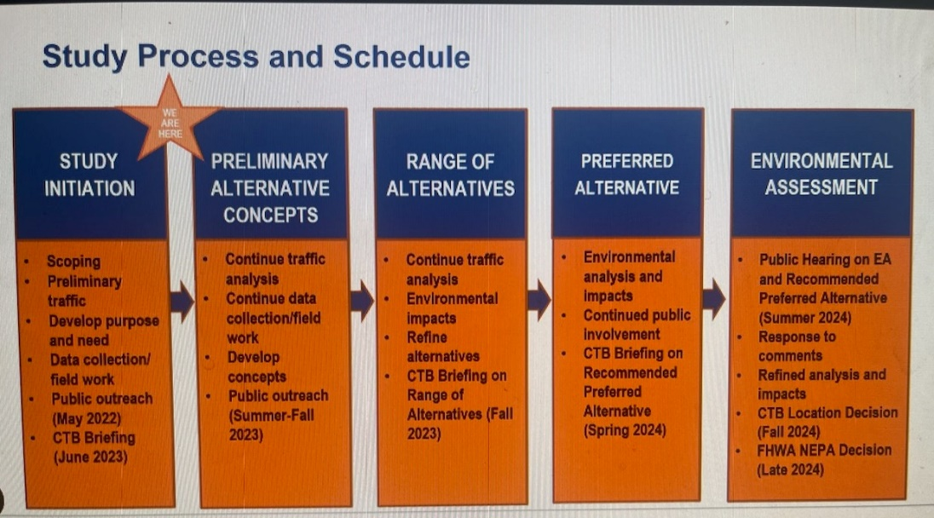
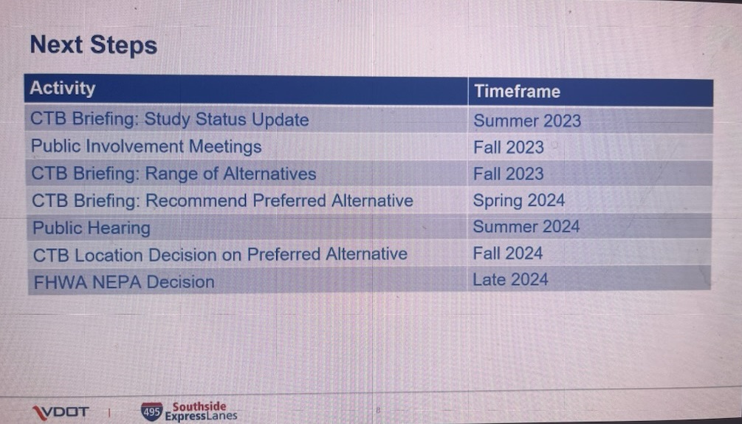
Susan, along with Nick Meese and Justin McNaul, discussed the 495 NEXT (Northern Extension) project. It is an approximately $660M, 2.5 mile extension of the 495 Express Lanes from I-495 and Dulles Corridor interchange to George Washington Memorial Parkway in the vicinity of the American Legion Bridge.
It will create additional express lanes access at Dulles Toll Road and Dulles Access Road interchange and George Washington Memorial Parkway Interchange.
It is a public private partnership project between VDOT and Transurban through 2087. There will be two tolled lanes in each direction on I-495 and will be free for use by HOV-3+ vehicles and transit vehicles.
Susan noted that there is another project just getting underway—the bi-directional study of I-95 and TAGS may want to keep tabs on it. It looks at the corridor from Opitz Boulevard to the Springfield Interchange and adds potentially one additional lane in reverse direction of what express lanes are operating.
- Malcom Watson from FCDOT’s Coordination & Funding Division provided an update on Transaction 2050, which is the TPB’s long range plan. The schedule and milestones are shown from his presentation below:
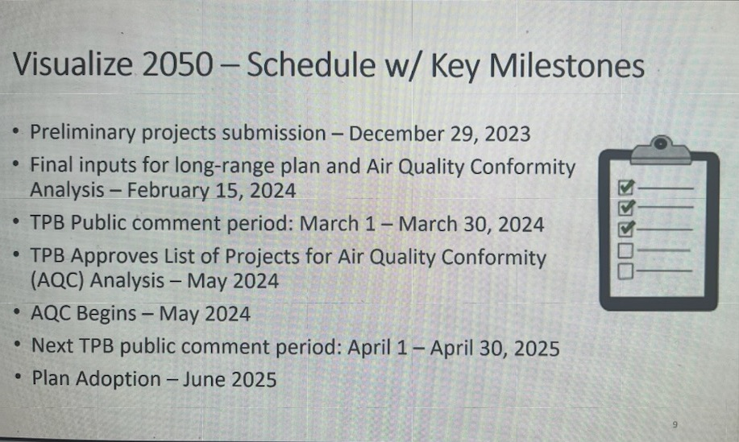
- Old Business/New Business
Joan offered a quick thank you to members and sponsors for supporting all these years and for spreading information on our projects.
She noted that there is no August meeting and that the next meeting will be in October. If anyone has inquiries on these or other projects or otherwise need some information let her know and she will include on the next meeting’s agenda.

The meeting adjourned at 2:44 pm with the next meeting set for October 4, 2023.

####

